The 5^{th(covid)} and 6th ANNUAL

HOLIDAY PARADE OF LIGHTS

On Main St. Rain or Shine
Sunday, December 19th @ 6:00pm

Penngrove, California

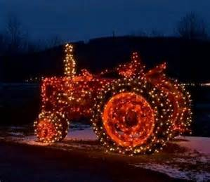

Come enter your tractors, big rigs, hay trucks, trucks, riding lawn mowers, bicycles, etc. All must be decorated with lights.

There are no fees or prizes, just fun for the family and community.

ASSEMBLE IN THE PARK BY 5:30. MAIN ST ON EACH END WILL BE CLOSED TO TRAFFIC BY 5:30PM

NAME_________________________________________PHONE______________________________
ADDRESS___________________________________________________________________________
E-MAIL_____________________________________________________________________________
TYPE OF ENTRY___________________________________________________________________*
In entering this event, I agree to abide by all rules and decisions of the Chairperson of the Parade and the Penngrove Social Firemen. I further agree to release the Penngrove Social Firemen and its members, all Penngrove businesses, all Sonoma County Agencies, SMART, and cooperating Penngrove Organizations from any and all responsibility for loss, damage, or injury to any person or property from my participation in this event, I will conduct myself in a safe, mannerly and lawful manner at all times during the parade.

***NO CANDY MAY BE THROWN FROM YOUR ENTRY. IT MUST BE PASSED OUT BY SOMEONE WALKING ALONG YOUR ENTRY. THIS IS A MAJOR SAFETY ISSUE SO CHILDREN WILL NOT BE INJURIED BY THE WHEELS.***
SIGNED_____________________________________________________ DATE______________________________
Entrants will not be permitted to participate unless a signed entry form is on record. Parents must sign for minors.
****parade entry form must be received by Thursday, December 16th . You may return it to Javamore Café, or fax to 707-794-1520, or email mrsjjava@hotmail.com Contact: Kim 707-794-1516 (Café) for more information****
This event is sponsored by the Penngrove Social Firemen—and the Sonoma County Board of Supervisors Thank you for joining in the fun

